*Discrete Event Simulation of Document Processing in Barangay Gaya-Gaya, San Jose Del Monte, Bulacan*

Caballero, Aliana M.   
*Technological University of the Philippines - Manila Department of Computer Science*Quezon City, Philippines  
[aliana.caballero@tup.edu.ph](mailto:aliana.caballero@tup.edu.ph)

Gullon, Sherlyn May   
*Technological University of the Philippines - Manila Department of Computer Science*Bacoor City, Philippines  
sherlynmae.gullon@tup.edu.ph

Fama, Ma. Diana M.   
*Technological University of the Philippines - Manila Department of Computer Science*Bacoor City, Philippines  
madiana.fama@tup.edu.ph

Manalo, Patrick Daniel  
*Technological University of the Philippines - Manila Department of Computer Science*Quezon City, Philippines  
patrickdaniel.manalo@tup.edu.ph

***Abstract*—** **Some people in Barangay San Jose Del Monte, Bulacan, are unfamiliar with the procedure of processing an application, particularly when obtaining a certificate that is required for personal reasons. Furthermore, it can be more difficult if you are unsure of what to do while obtaining the certificate that you require. Additionally, relying on the barangay, there may be hundreds or only a few processes of the application. It is, nevertheless, preferable to have some knowledge of the barangay procedure. As a result, the group proposed the concept of "Discrete Event Simulation of Document Processing in Barangay Gaya-Gaya, San Jose Del Monte, Bulacan." This simulation provides the state of the residents in the barangay document processing of Barangay Gaya-Gaya, San Jose Del Monte, Bulacan focuses on the queueing of the residents starting on the ongoing applications until about the end. It demonstrates the real-world activities in the barangay. Whereas offering you a process will simplify things by giving you a sequence of steps to follow, in order to achieve your goal. The Barangay Logbook and the manual observation of processing time are the basis for the simulation.**

***Keywords—******Barangay, Resident, Discrete Event Simulation, Simio, SMORE***

# Introduction

This study focused on analyzing and evaluating the waiting time of the residents obtaining the documents they requested in Barangay.  One of the most essential functions of a barangay is to act as the community’s principal planning and executing unit for government policies, plans, programs, projects, and activities. It also serves as a platform for the people‘s collective views to be voiced, and discussed, and for disagreements to be handled peacefully [1]. Barangays are in charge of a wide range of data, including barangay profiles, resident profiles, barangay IDs or clearance, cases, and so on.

Barangays have been under pressure to meet expectations while also dealing with increasing changes in the population [2]. Though some barangays have begun to employ computers and electronic gadgets to conduct official transactions, the majority remain reliant on manual processes like writing the time and the documents they need at the front desk. One of them is Barangay Gaya-Gaya in the city of San Jose, Del Monte, Bulacan. The population of Barangay Gaya-Gaya was 56, 896 in 2020 and is still increasing, which can affect the waiting time for requested documents by the residents [3]. Good services are obtained by knowing the process of requesting documents. It also creates good communication between barangay officials and residents. Barangay officials must advise residents on how to expedite the processing of their needs.

The most common approach to reducing the waiting time of the residents is to conduct trials under controlled conditions using real-life barangays. For this modeling purpose, it was suggested that Discrete Event Simulation (DES) be used. It is a method for simulating real-world systems that may be broken down into a series of conceptually distinct processes that develop independently across time [4]. The data came from barangay Gaya-Gaya to guide the creation of modeling that can help solve the problem of the quick processing of documents or conduct a what-if scenario such as one window is not available and so on.

People are more engaged in barangays at the bottom of the bureaucracy than in other government divisions. Individual barangay empowerment might eventually lead to a stronger, more resilient, and wealthier society.

# Related work

Discrete Event Simulation (DES) is a method to imitate the behavior of an operational system or process using an analog conceptual model on a computer. At a medium degree of abstraction, discrete event simulation focuses on the processes in a system. Specific physical features, such as vehicle geometry or train acceleration, are usually not included. Manufacturing, logistics, and healthcare industries all use discrete event simulation modeling [5]. The simulation would be a useful tool to demonstrate the process using 2D or 3D graphic representation [6]. This simulation portrays occurrences in Barangay Gaya-Gaya as well as the process of obtaining certification requests in this place. Furthermore, according to Liu L. and Ioannou P., constructing graphical models and running simulations straight on the models offers an appealing manner of performing modeling. It is necessary for the analysis of demand patterns in time as well as the availability of facilities and resources.

Throughout the study, a simulation model will be used to estimate the time it will take to process the documents and how long residents will have to wait. To create sophisticated process animations that integrate model data, material handling procedures, and logic in order to assess and improve business operations we decided to use the Simio application to create the discrete event simulation of document processing in barangay Gaya-Gaya, San Jose Del Monte, Bulacan. Simio Simulation was the tool we used to construct more suitable estimates of waiting time [7]. This tool is suitable when it comes to analysis and conventional measurements of time-in-system. Simio would be used to create SMORE plots for each of the time buckets. It also creates bins for each category and hour. It is a great tool to configure the system before it implements and the 3D animation will help to visualize the process.

In a comparison project, a discrete event simulation of health care systems was created in order to enhance patient flow while lowering healthcare delivery costs and enhancing patient satisfaction. Discrete-event simulation has become a popular and successful decision-making tool for maximizing patient flow while lowering healthcare delivery costs and enhancing patient satisfaction [8]. Where this discrete event simulation of healthcare systems has comparable objectives and applications for barangay Gaya-Gaya solutions to improve people's satisfaction and be flexible in terms of detail and complexity of the simulation model. Without needing to go to a physical location, simulation allows you to answer 'what if' questions and scenarios in your mind. It aids in the detection of material, information, and product flow bottlenecks.

Subsequently, the simulation model was applied to evaluate the cases in Barangay Gaya-Gaya document processing. The first case was aimed at finding a way of reducing the waiting time for the residents in obtaining documents. The second case examined the effect of another window on the system as a result of changes in resident queuing. The third case is evaluating the available options. In the last case, it analyzes the impact of other available alternatives on the resident queue [9]. As a result, the simulation model was utilized to thoroughly examine complicated systems.

# materials and methods

## Data Collection

In a data collection, the information regarding residents' processing times of documents had to be collected in the logbook from barangay Gaya-Gaya. The arrival time of the residents in the barangay will be used in the data collection. Additionally, the logbook will be used to get the arrival time of inhabitants per hour. Furthermore, using recorded data, the percentage of residents who require the document was determined. Interviews with barangay officials and questions they responded to during the research were other significant sources of information.

The flow of the simulation that will be developed is shown in Figure 1. Arrival is the logbook depiction of a real-life process that the discrete event simulation begins with. The front desk will then question you about your requirements before providing you with a form. It will be sent to the departure if the form does not exist in someone's event. If forms are accessible, you will present them in the window to obtain the requirements or certificate that you require, and the event will be ready to depart. All discrete occurrences within the specified data are reproduced when the simulation is run. If the simulation has finished running, it will automatically end at this moment.

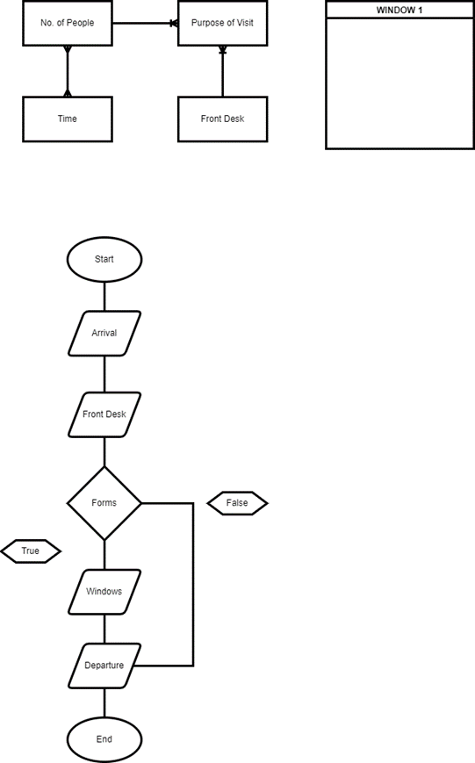

**Figure 1**: Barangay Flowchart

## Discrete Event Simulation Model Development

One of the most crucial steps a simulation must take is to select the appropriate software. Simio simulation software was chosen for this project because it offers a novel object-based paradigm that has been successfully applied in a variety of systems, including airports, hospitals, ports, mining, contact centers, supply chains, and manufacturing.

The simulation model's initial stage is to fully comprehend and specify the empirical system, encompassing all occurrences, their sequences, and logical requirements. The relevant input and output parameters linked with each event in the process were also determined as shown in figure 2. Using important process events, parameters of interest, and their logical order, a discrete event simulation was created. The collected data was then fed into the model, which was validated. The barangays' what-if possibilities are analyzed using the verified simulation model.

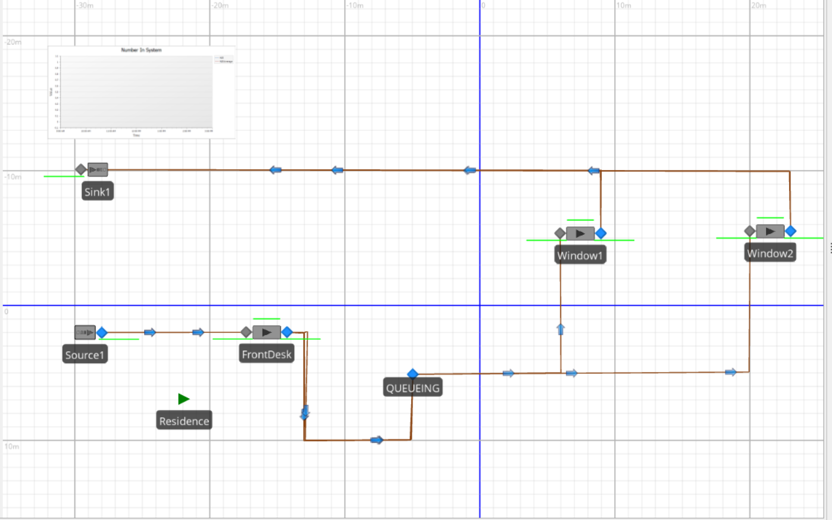

**Figure 2**: Initial Simulation Flow

Simio and other object-based modeling tools are excellent for quickly creating models. Simply drag items into the workspace, configure their attributes, and your model is ready to run. Figure 2 shows the initial simulation of how the resources are connected to each other. The source shows the arrival of the residents in the barangay, and there are 3 servers for the front desk and 2 windows.

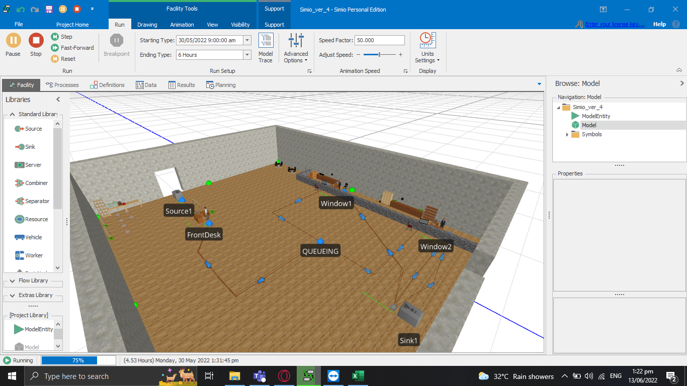

**Figure 3**: 3D Barangay Simulation

Figure 3 shows the 3D simulation of barangay document processing. We applied the symbol in the source to look like a human. We added a person in the windows to represent the barangay personnel who process the documents of the residents. Lastly, import symbols into the place to finally become a representation of the barangay office and to simulate barangay Gaya-Gaya for one day.

## *Data Analysis*

In this simulation, we obtain a huge amount of data from 50 residents of barangay Gaya-Gaya who process their required certificate on-site and calculate the time spent at each station. We use the collected data to recreate or mirror real-world conditions to establish the optimal course of action and validate a model. This is the data that is related to the Simio source, as illustrated in figure 4. Where the residents are computed, how many will come out in the source that follows the data acquired.

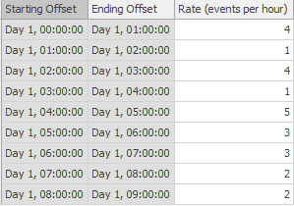

**Figure 4**: Resident's Rate per Hour

Throughout the data analysis process, the proponents observed that data is acquired in real-time and from primary writings. It is preferable to match observed data to a theoretical probability distribution before using it in a simulation model. The simulation model is then driven by values generated by the theoretical probability distribution. The time unit that should be utilized for simulation input data relating to time intervals is an important consideration. Using a relative, interarrival time approach, it is frequently less labor-demanding to collect the data accurately in the first place.

All across the data analysis, the probability distribution used in this study was Poisson Distribution. The model and simulation used to describe the distribution of rare occurrences in a large population are made possible by the distribution process. Throughout the process, this distribution helps to identify the discrete probability distribution that expresses the probability of a given number of events occurring in a fixed interval of time or space if these events occur with a known constant mean rate and independently of the time since the last event. Additionally, the Poisson Process helps the model to identify the series of discrete events where the average time between occurrences is known, but the specific timing of events is random. An event's arrival occurs independently of its predecessor; waiting time between events is memoryless.

# Results and discussion

Simulations were conducted to investigate and analyze the situation in Barangay Gaya-Gaya. The use of DES in models appears to be a suitable strategy, and what-if scenarios may be implemented. It could be used to test the effects of failures, breakdowns, and crashes, and forecast how to overcome them in Barangay. In addition, creating a detailed presentation and experimentation using a 3D model is possible.

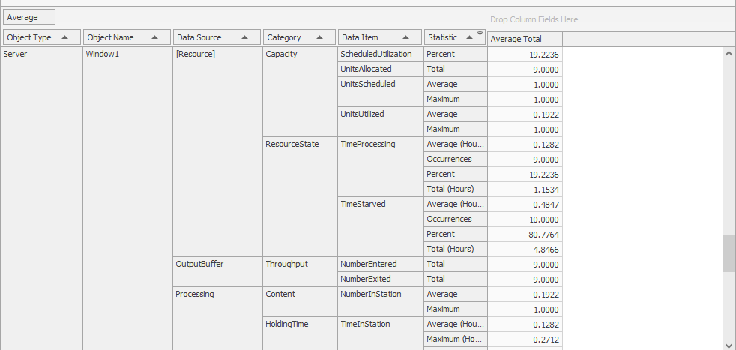

**Figure 5**: Statistical results generated by Simio

Figure 5 shows the model's outcomes as of right now since these statistical results were produced by the Simio. But it is feasible to conduct the what-if scenarios and show the results of that simulation in the barangay, then determine the optimal option for each set of resources, such as the front desk, adding a window, and reducing residents' waiting time. These first findings appear to be a nice motivator for moving further with simulation in SIMIO.

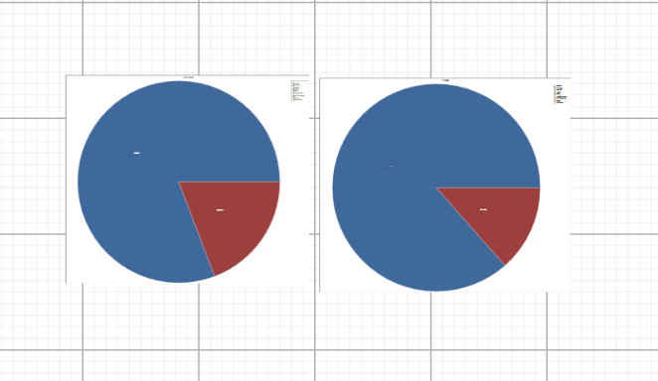

**Figure 6a**:Window 1 and Window 2 Pie Chart

Figure 6a represents the total average function of Windows in 9 hours. The color red in the pie chart shows the average of windows 1 and 2 that process documents. During the simulation, there is a connector named "queue" where the residents need to line up in that place if the window is not yet available.

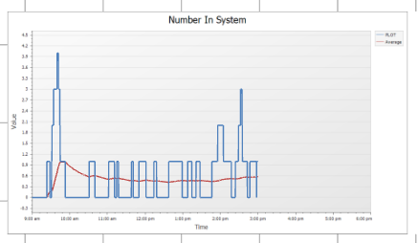

**Figure 6b**: Systems represented by Line Graph in Numbers

Figure 6b shows the number of systems using a line graph, where the Y-axis is the value and the X-axis is the time per hour of the barangay Gaya-Gaya. The blue line indicates the plot value of the number of residents arriving each hour, and the red line is the average of all the statistics.

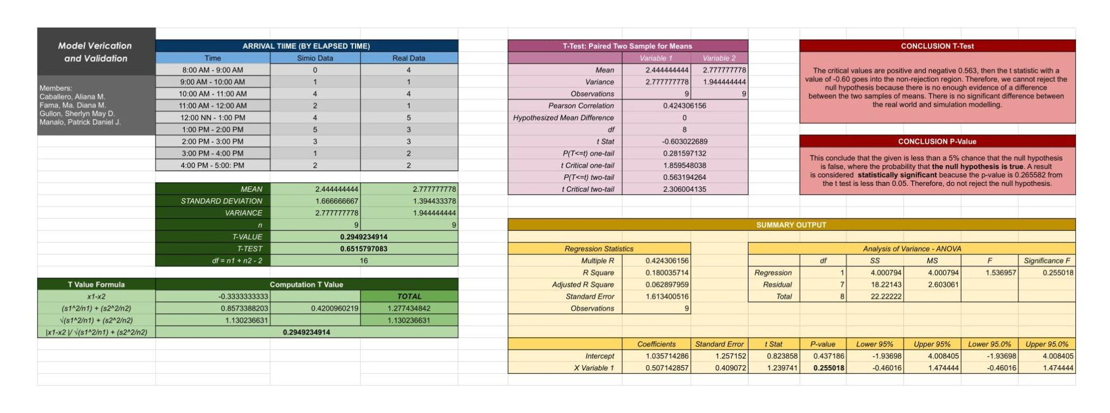

**Figure 7**: Verification and Validation of the Simulation

Figure 7 shows the validation of the simulation comparing the data from simio and data from the real-world process. From the standpoint of the model's intended uses, validation is the process of assessing how well a simulation model and the data it uses to represent the real world.

The t statistic with a value of -0.60 enters the non-rejection zone when the critical values are positive and negative 0.563. As a result, we cannot rule out the null hypothesis since we lack sufficient data.

This concludes that the given is less than a 5% chance that the null hypothesis is false, where the probability that the null hypothesis is true. A result is considered statistically significant because the p-value is 0.265582 from the t test is less than 0.05. Therefore, do not reject the null hypothesis. There is no significant difference between real-life barangay gaya-gaya and the simio simulation.

# conclusion

The problem raised in the article is that there are instances where there is a higher demand for accommodation during particular times of working hours. Moreover, this simulation study we created will enable residents to get a better understanding of how the barangay Gaya-Gaya processes documents to reduce the need for accommodations while the process is underway.

A model has been proposed for simulating the Barangay Gaya-Gaya for document processing. The validity range of the model includes entering the doors of the residents to obtain the documents requested. The model is employed to establish the what-if scenarios in the barangay, like if the one window is not available. Virtual waiting time is the most important performance metric for residents, and because few service systems are truly immobile, arrival time is usually important. The implementation of such a system allows for reduced risks when you want to process your documentation in the barangay Gaya-Gaya personally.

The simulation model will be enhanced for future study using residence feedback. In the study, we will add five other barangays in the Bulacan region that are located and have the same research criteria as barangay Gaya-Gaya. In order to improve management in the other barangays, consider the crucial part to calculate the simulation model's effectiveness and apply it to the other barangays.

##### References

1. A. Lachica, “The local government code of the Philippines book iii local government units title one. -the barangay chapter 1. -role and creation of the barangay,” 2015.
2. C. O. Carpio, “Barangay Management System,” *Ijmrap.com*. [Online]. Available: http://ijmrap.com/wp-content/uploads/2020/07/IJMRAP-V3N1P78Y20.pdf. [Accessed: 16-May-2022].
3. “Gaya-gaya, San Jose del Monte, Bulacan Profile – PhilAtlas,” *Philatlas.com*. [Online]. Available: https://www.philatlas.com/luzon/r03/bulacan/san-jose-del-monte/gaya-gaya.html. [Accessed: 16-May-2022].
4. “Discrete Event Simulation,” Upenn.edu. [Online]. Available: https://www.med.upenn.edu/kmas/DES.htm. [Acessed: 17-May-2022].
5. *Discrete event modeling*. Discrete Event Modeling – AnyLogic Simulation Software. (n.d.). Retrieved June 8, 2022, from https://www.anylogic.com/use-of-simulation/discrete-event-simulation/
6. P. Vik, L. Dias, G. Pereira, J. Oliveira and R. Abreu, "Using SIMIO for the specification of an integrated automated weighing solution in a Cement plant," Proceedings of the 2010 Winter Simulation Conference, 2010, pp. 1534-1546, doi: 10.1109/WSC.2010.5678915.
7. J. S. Smith and B. L. Nelson, "Estimating and interpreting the waiting time for customers arriving to a non-stationary queueing system," 2015 Winter Simulation Conference (WSC), 2015, pp. 2610-2621, doi: 10.1109/WSC.2015.7408369.
8. Nevins, M. R., Macal, C. M., & Joines, J. C. (1998). A discrete-event simulation model for seaport operations. Simulation, 70(4), 213-223.
9. K. Munasingha and V. Adikariwattage, "Discrete Event Simulation Method to Model Passenger Processing at an International Airport," 2020 Moratuwa Engineering Research Conference (MERCon), 2020, pp. 401-406, doi: 10.1109/MERCon50084.2020.9185370.